**COM427 – Practical 12**

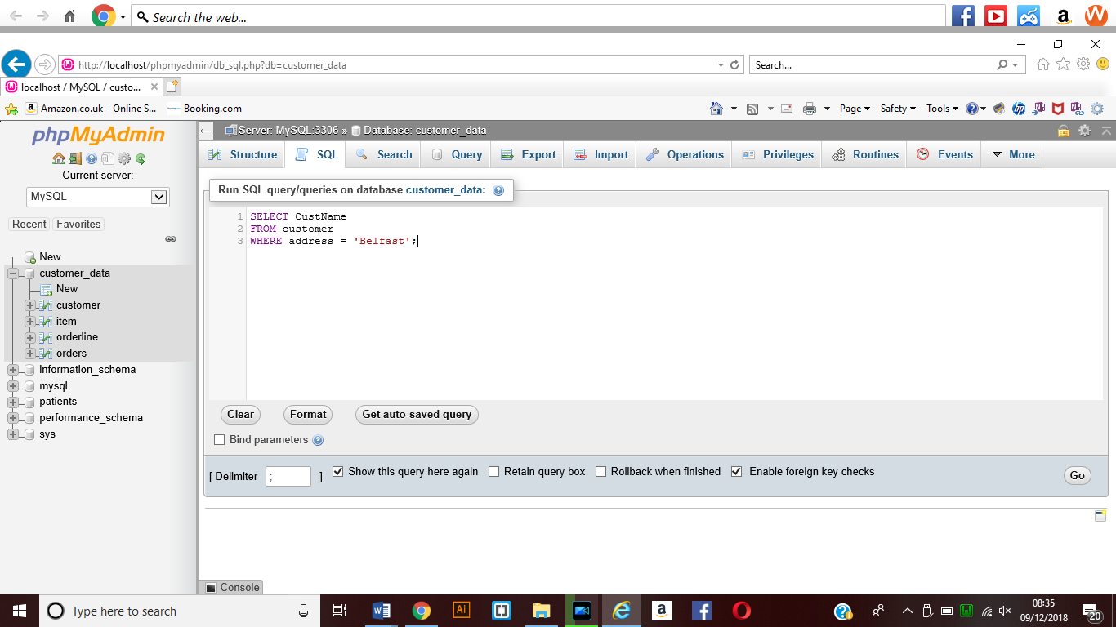1201 – Select Number of customers in customer table whose address is Belfast.

This shows the SQL statement which has been entered into the SQL window within the SQL window of the PHPMyAdmin

The SQL Statement was written as

**SELECT CustName**

**FROM customer**

**WHERE address = ‘Belfast’;**

**Result of SQL Select Statement:**

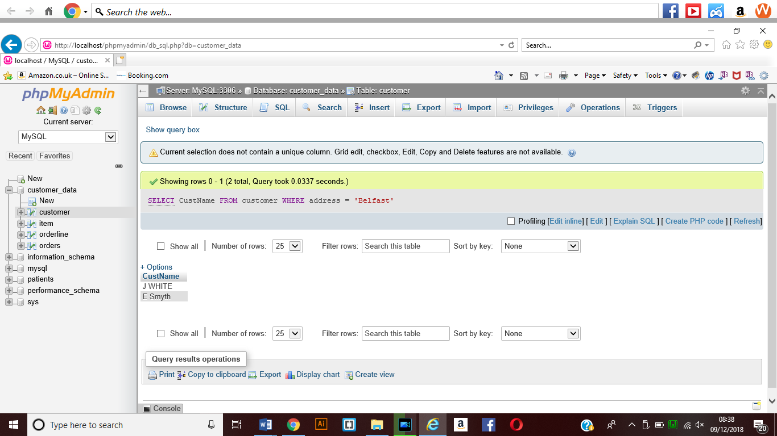

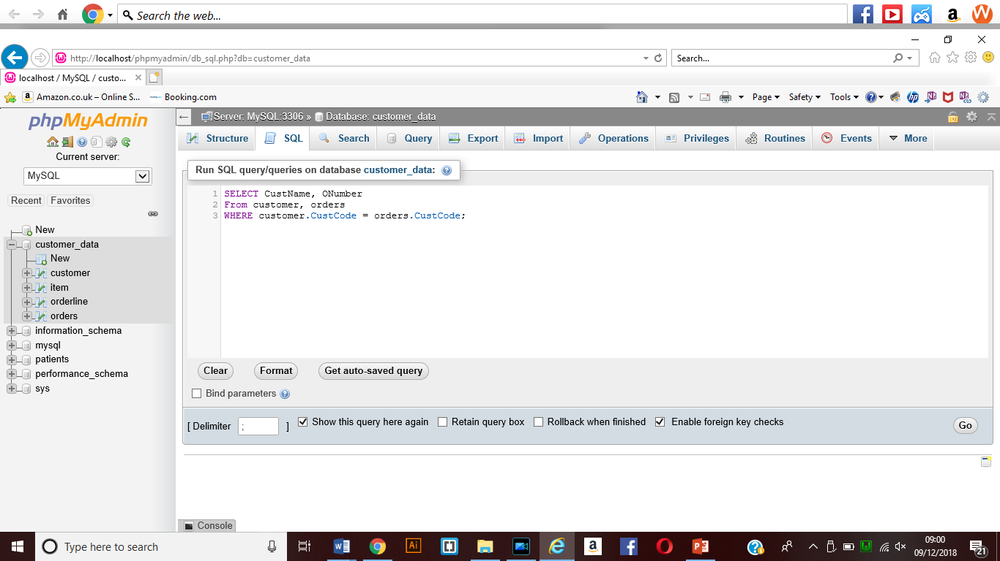1202 – Select query to tell the number of orders placed by each customer.

This shows the Select statement that had been entered into the phpMyAdmin window.

The SQL statement that had been entered.

**SELECT CustName, ONumber**

**FROM customer, orders**

**WHERE customer.CustCode = Orders.ONumber;**

This should display the customer name and their order from the database.

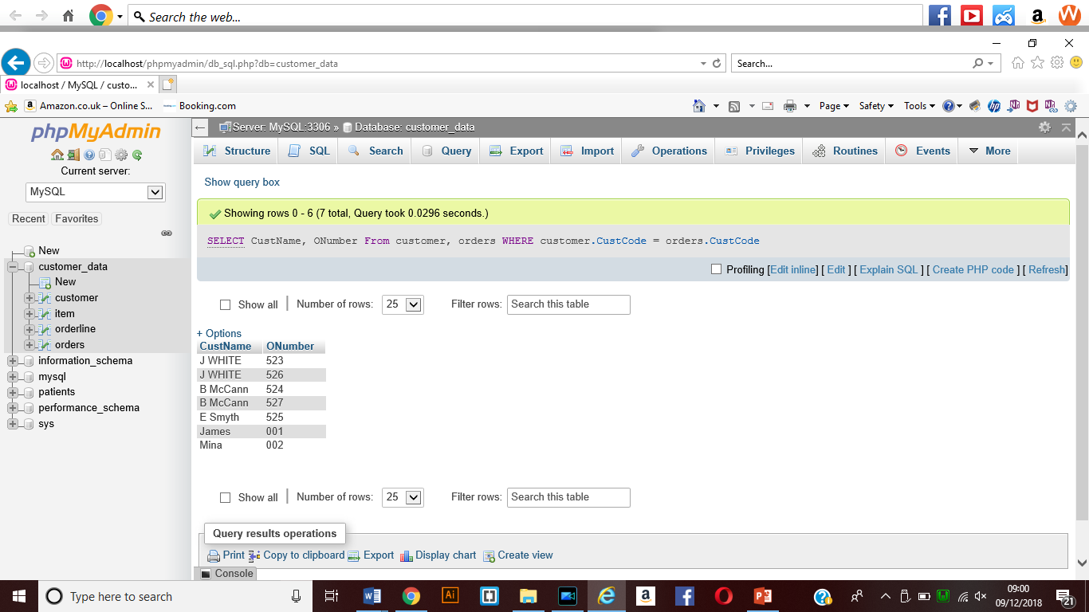**this shows the results of this select query when it has been run within phpMyAdmin.**

1203 – Select query to get all custcode from orders whose number of orders is 1.

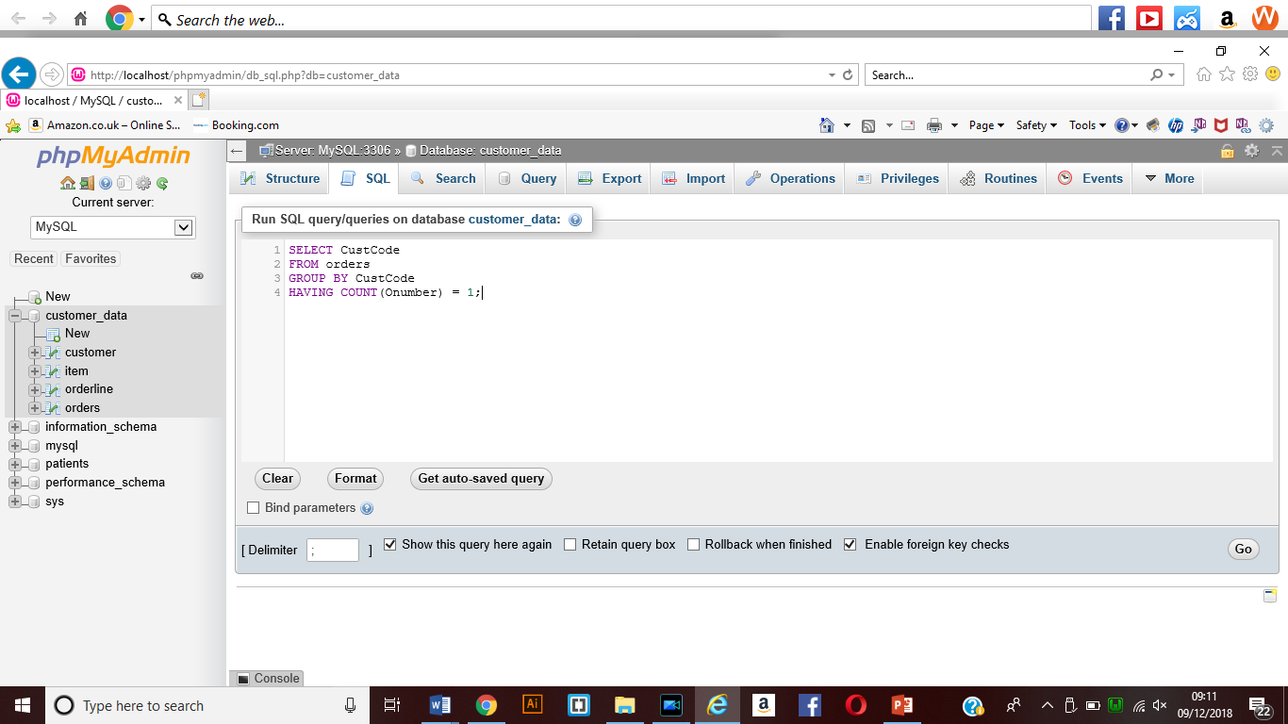

**This will display only records of the customers who have place one order.**

**SQL STATEMENT WRITTEN INTO THE SQL WINDOW**

**SELECT CustCode**

**From orders**

**GROUP BY CustCode**

**HAVING COUNT (ONumber) = 1;**

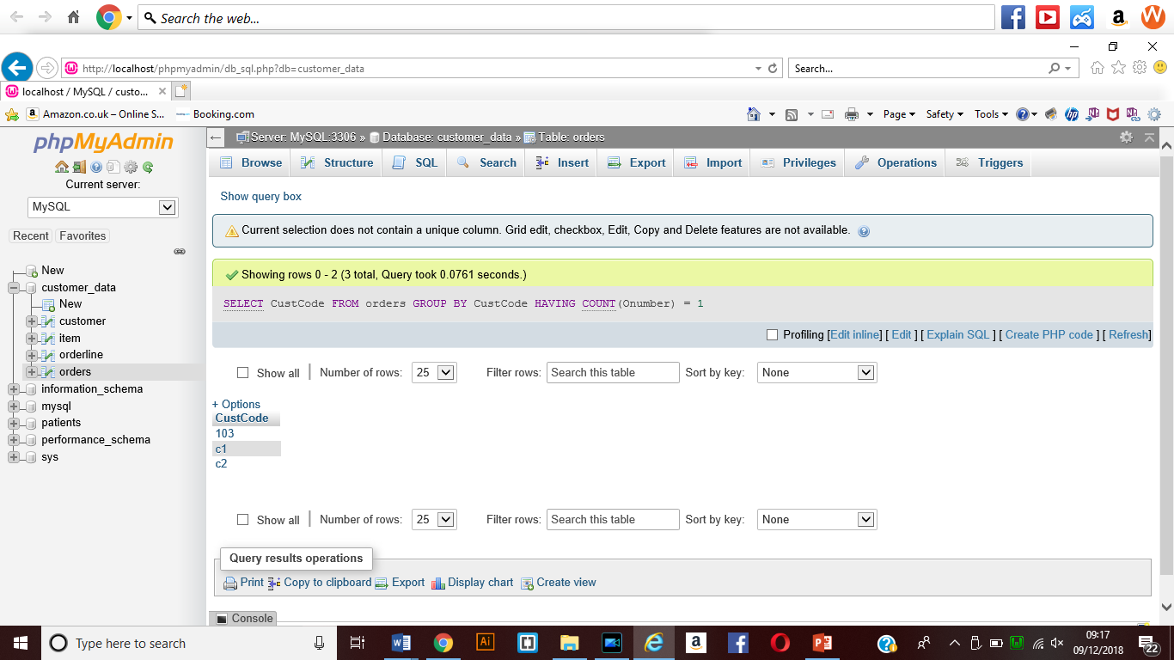

**This shows the results from the orders table where only one order has been received**

**1204 – Select Query to get all itemcode from orderline table with quantity great than 20.**

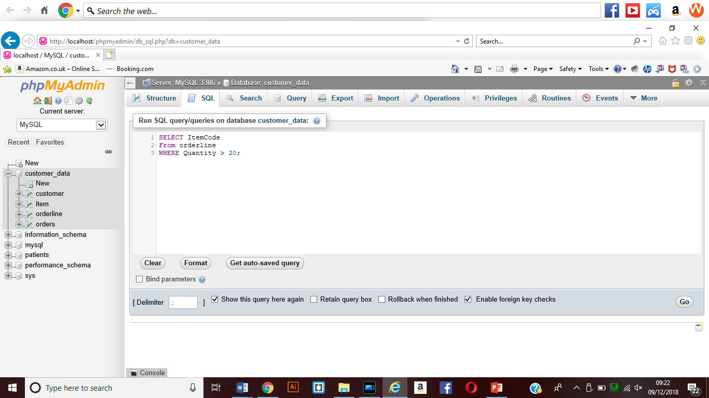 **This shows the select query when it has been written to display the item codes with a quantity greater than 20.**

**The SQL statement written into the SQL window**

**SELECT ItemCode**

**FROM orderline**

**WHERE Quantity > 20;**

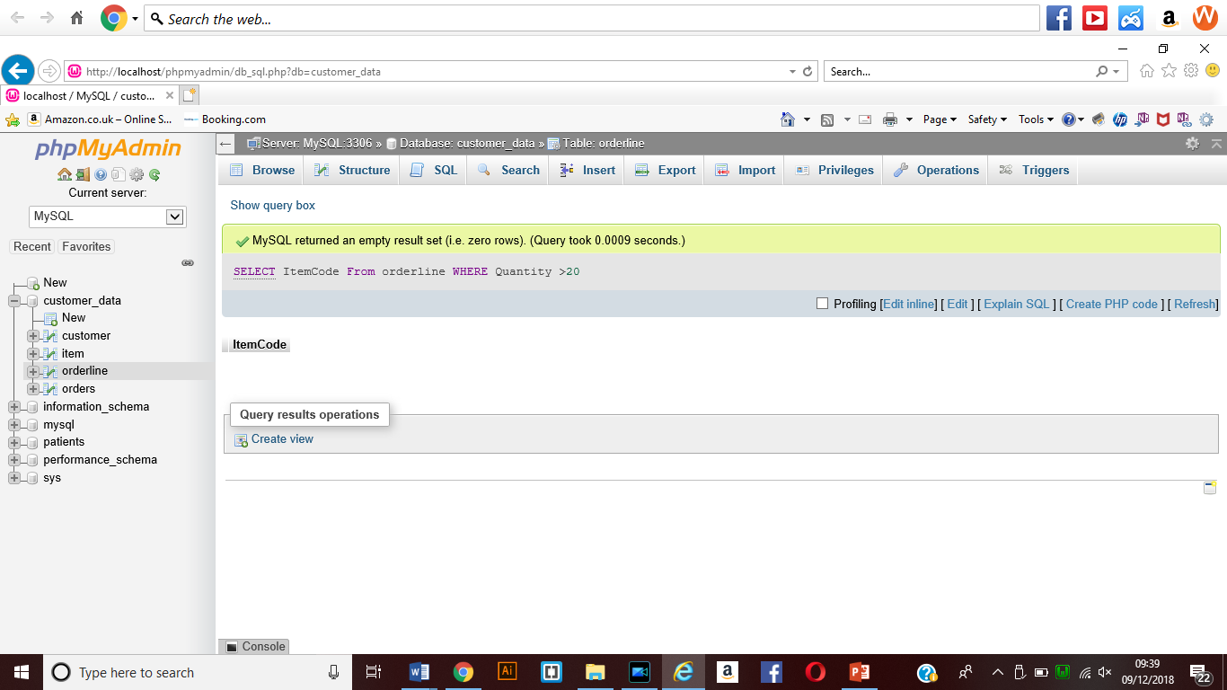 **This shows the results that I have been given when the Query is run and it returns an empty value for some reason.**

**1205 – Select Query to get a unique list of all itemcode from orderline;**

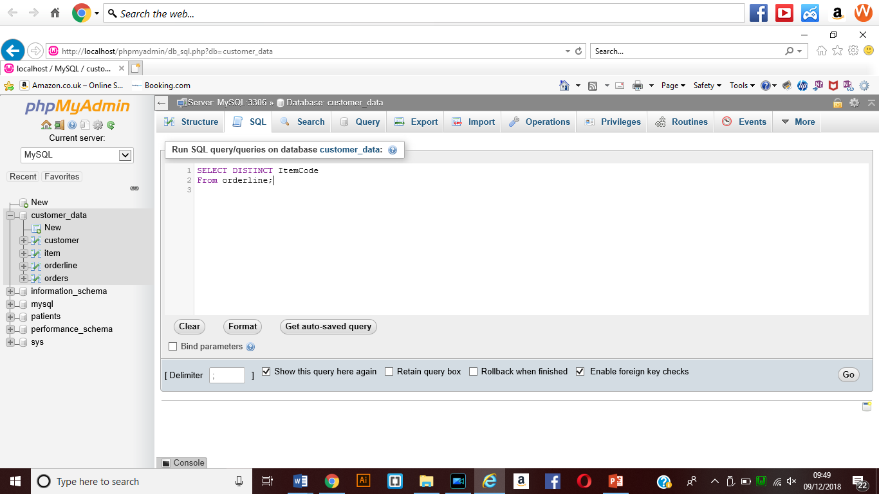**This SQL Statement will display a unique list of values**

**SQL STATEMENT WRITTEN**

**SELECT DISTINCT ItemCode**

**From orderline;**

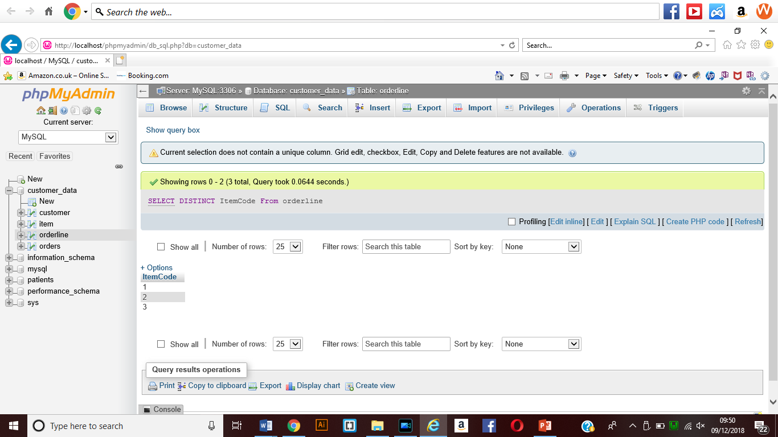

**The results of the distinct ItemCodes which have been entered.**

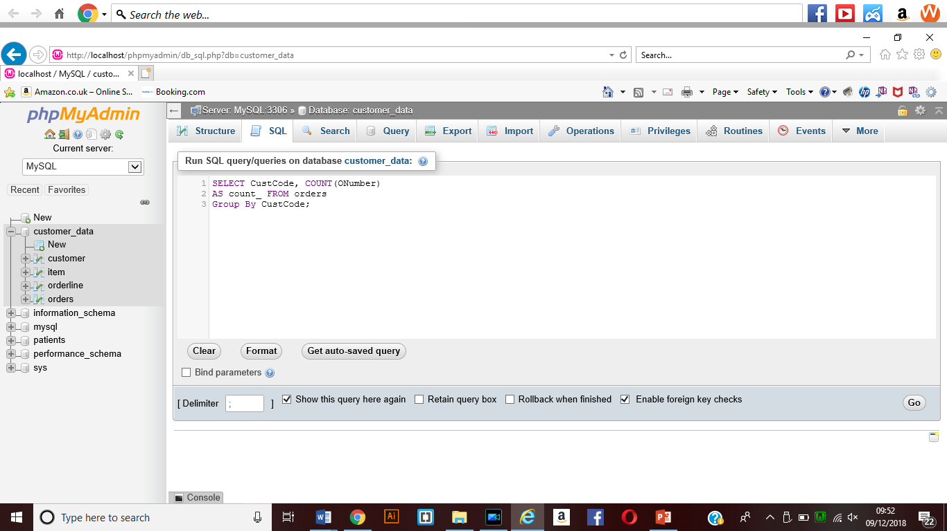**1206**

**Shows the SQL STATEMENT WRITTEN into PHPMYADMIN.**

**SQL STATEMENT**

**SELECT CustCode, COUNT(ONumber)**

**AS count_ FROM orders**

**GROUP BY CustCode;**

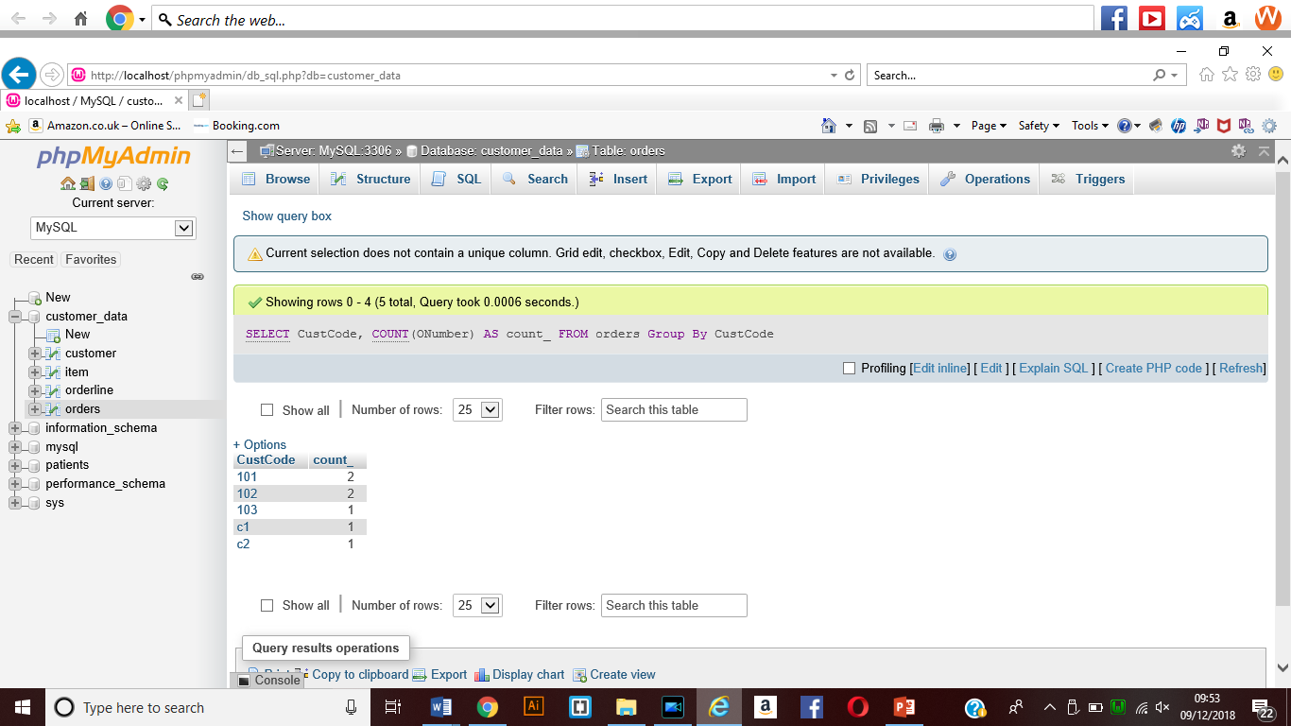**Result**

**1207 – Select query to get the names of all customers with their order numbers**

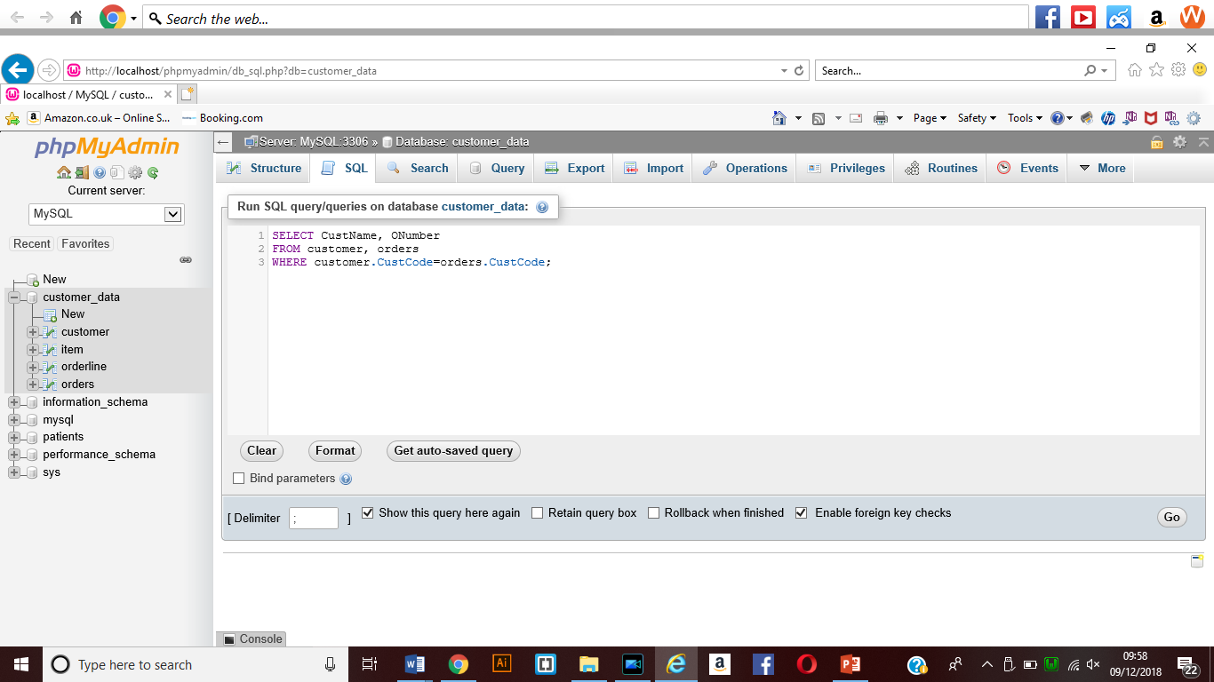**This shows the SQL STATEMTENT WITHIN phpMyAdmin.**

**Command written**

**SELECT CustName, ONumber**

**FROM customer, orders**

**WHERE customer.CustCode=orders.CustCode;**

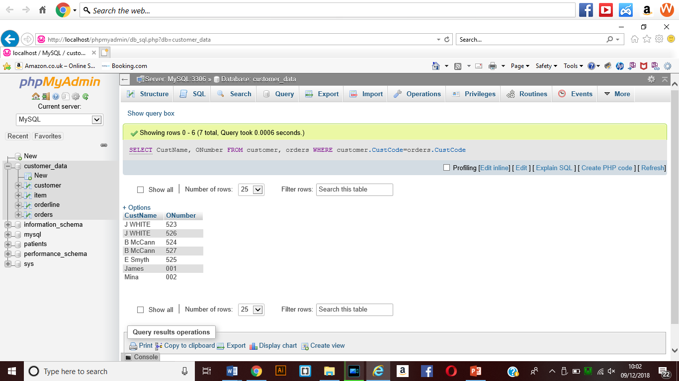**Result**

**1208 – Select query to get the names of all customers with the number of orders**

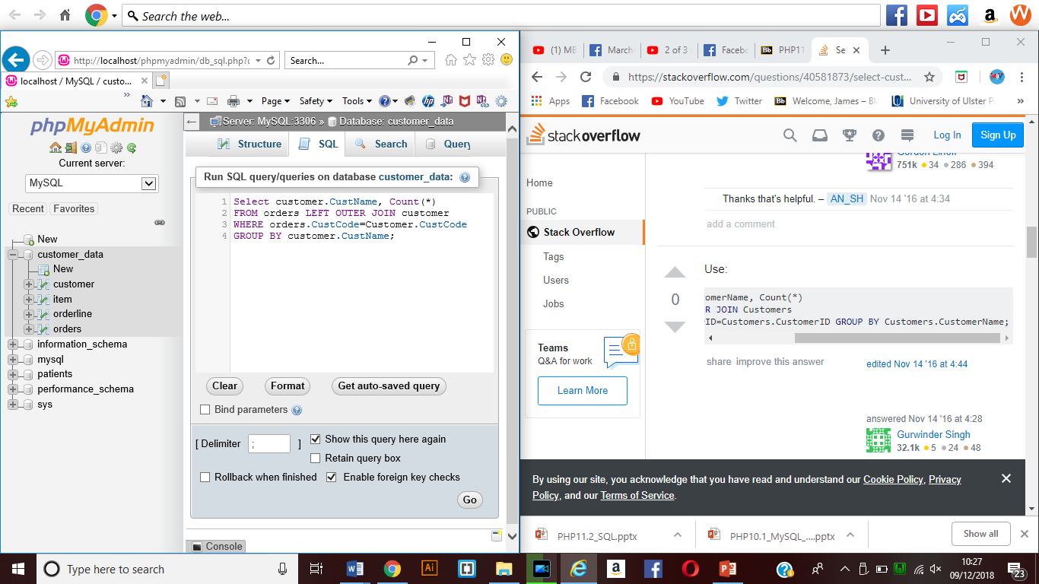

**This shows the SQL query that had been written to allow me to select the customer name and the number of orders placed by each customer**

**SQL QUERY Written was**

**SELECT customer.CustName, COUNT(*)**

**FROM orders JOIN customer**

**WHERE orders.CustCode=customer.CustCode**

**GROUP BY customer.CustName;**

**Result**

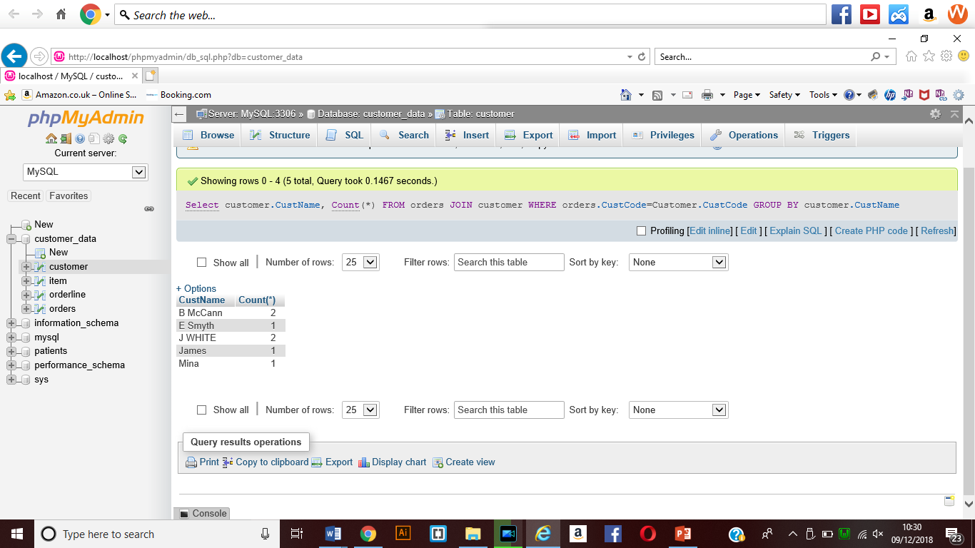

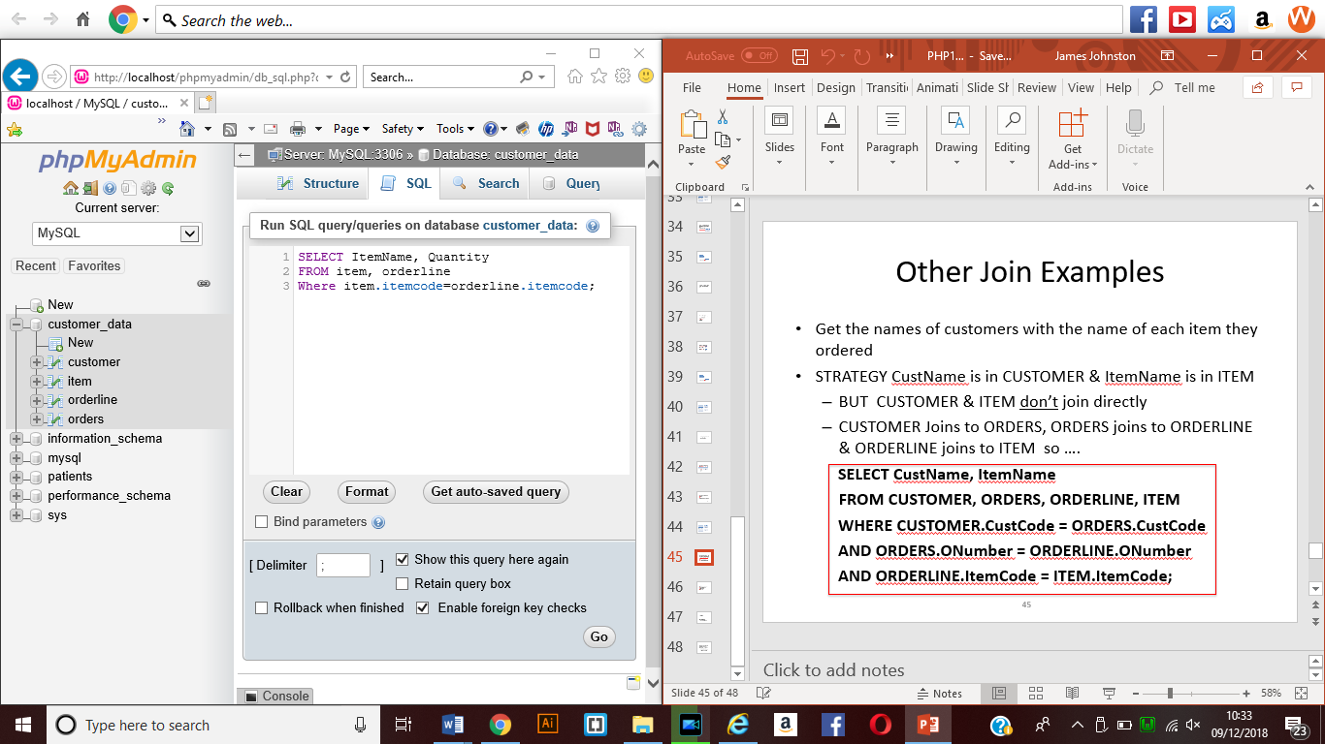**1209 – Select Query to get names of all items with their total quantity being ordered.**

**SQL STATEMENT IN MYSQL database.**

**SQL Query written in phpMyAdmin**

**SELECT ItemName, Quantity**

**FROM item, orderline**

**WHERE item.itemcode = orderline.itemcode;**

**Result**

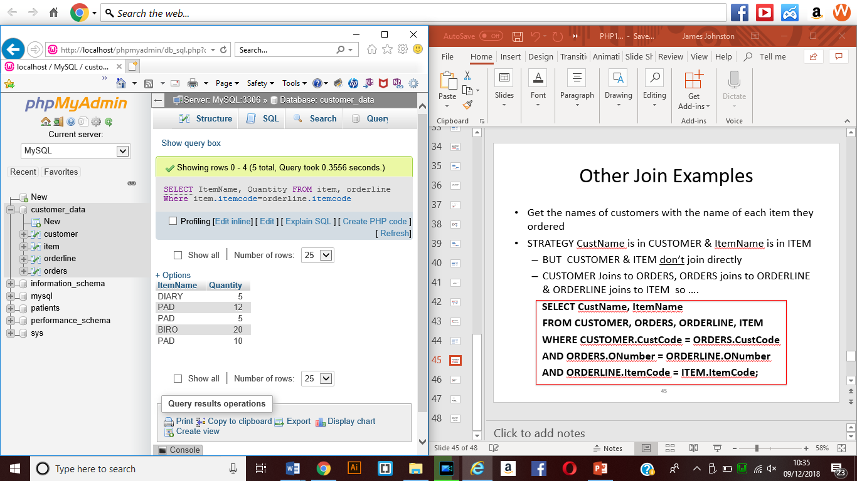

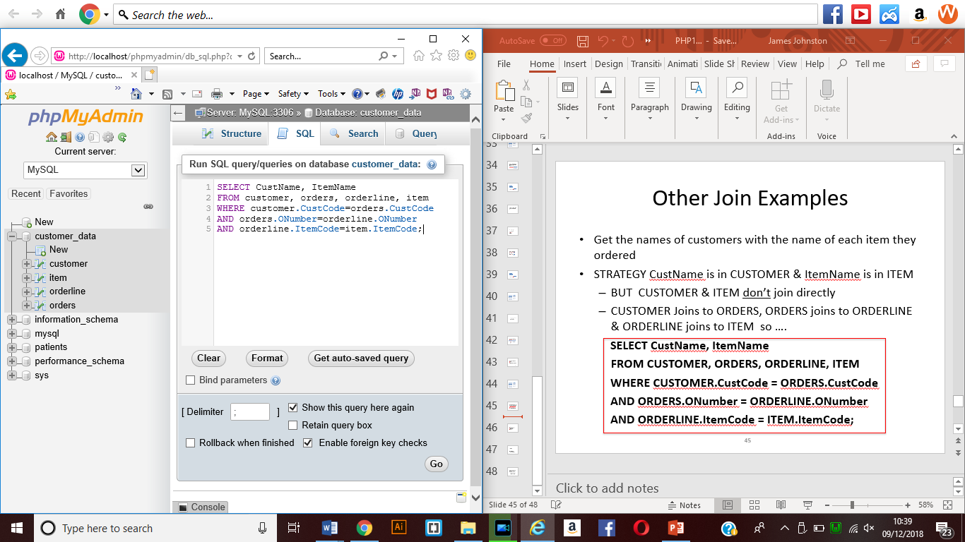**1210 – SELECT QUERY with the names of customers with the name of each item they have ordered  
  
This shows the SQL STATEMENT WHEN WRITTEN INTO THE SQL WINDOW**

**SQL STATEMENT**

**SELECT CustName, ItemName**

**FROM customer, orders, orderline, item**

**WHERE customer.CustCode=orders.CustCode**

**AND orders.ONumber=orderline.ONumber**

**AND orderline.ItemCode=item.ItemCode;**

**Result**

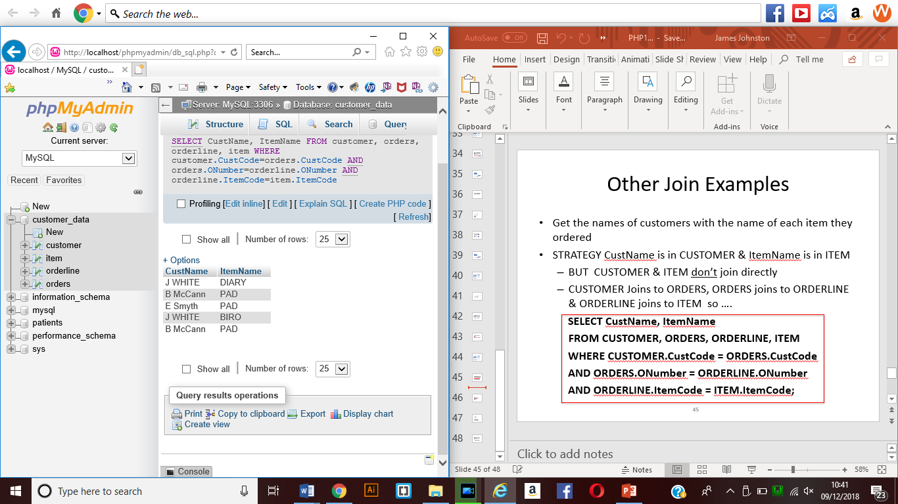

1211 – Select statement to get theitem codes of items on orders with numbers abover 525 whose quantities are below 12.

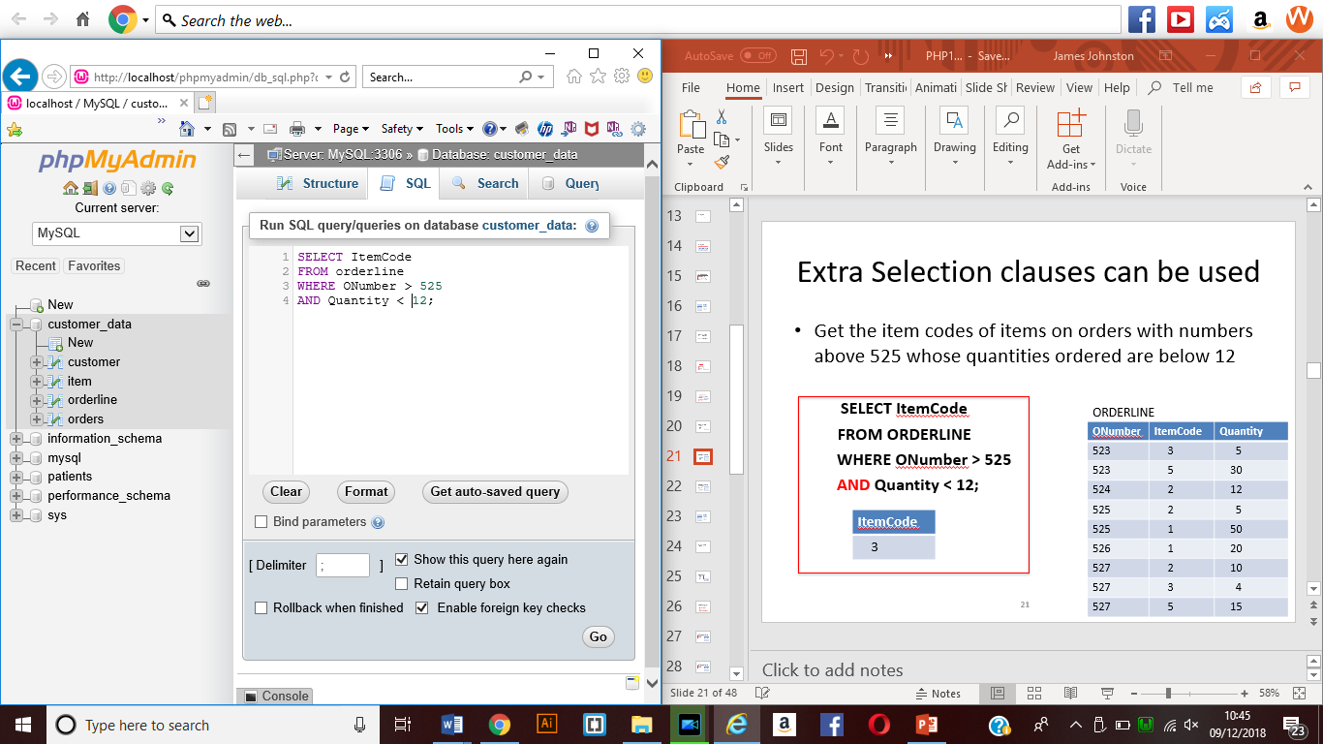

SQL STATEMENT WRITTEN IN

SELECT ItemCode

From Orderline

WHERE ONumber >525

AND Quantity <12;

Result

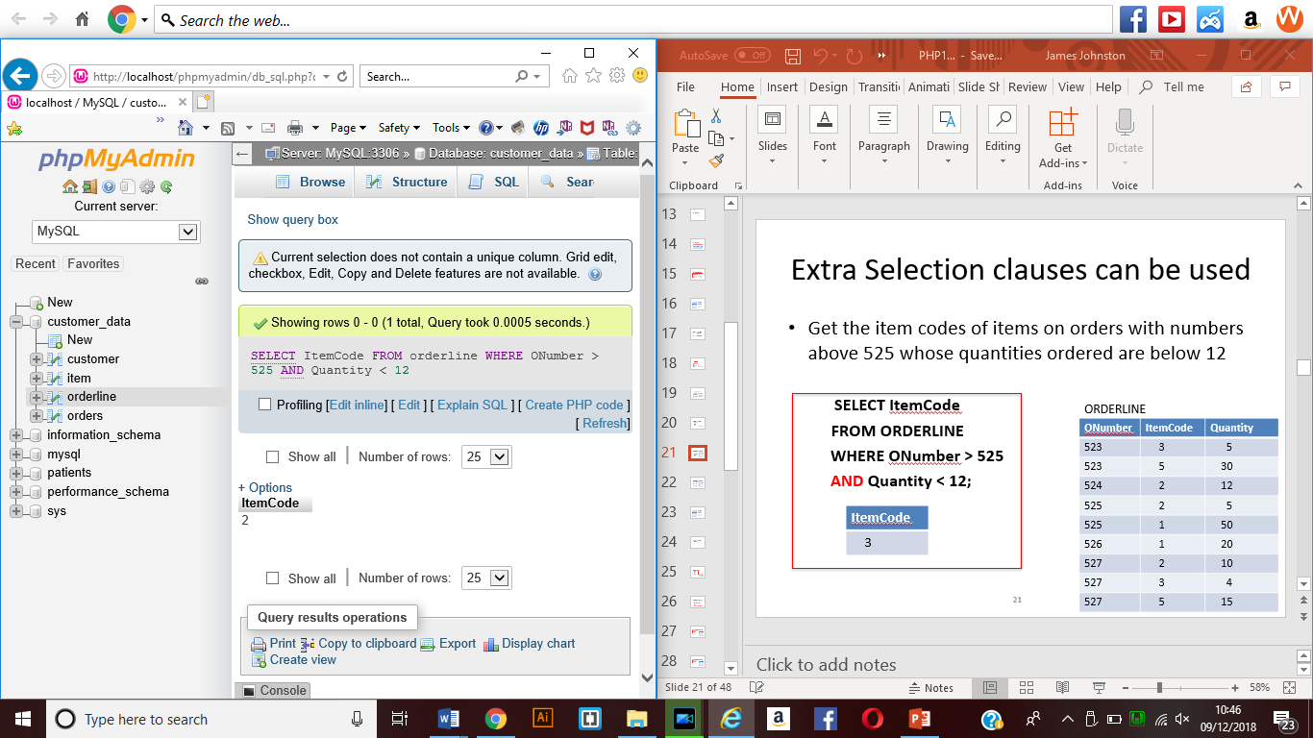

Alternate select

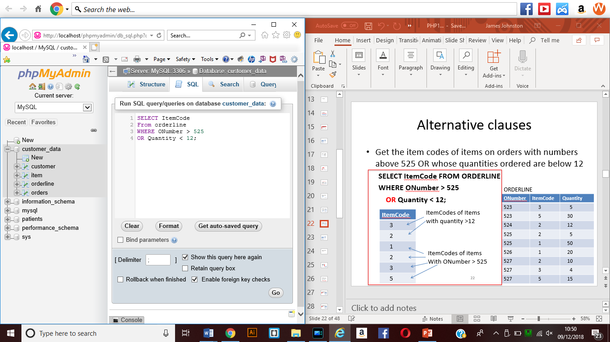

Select statement

SELECT ItemCode

FROM orderline WHERE ONUMBER > 525

Or Quantity <12;

Result

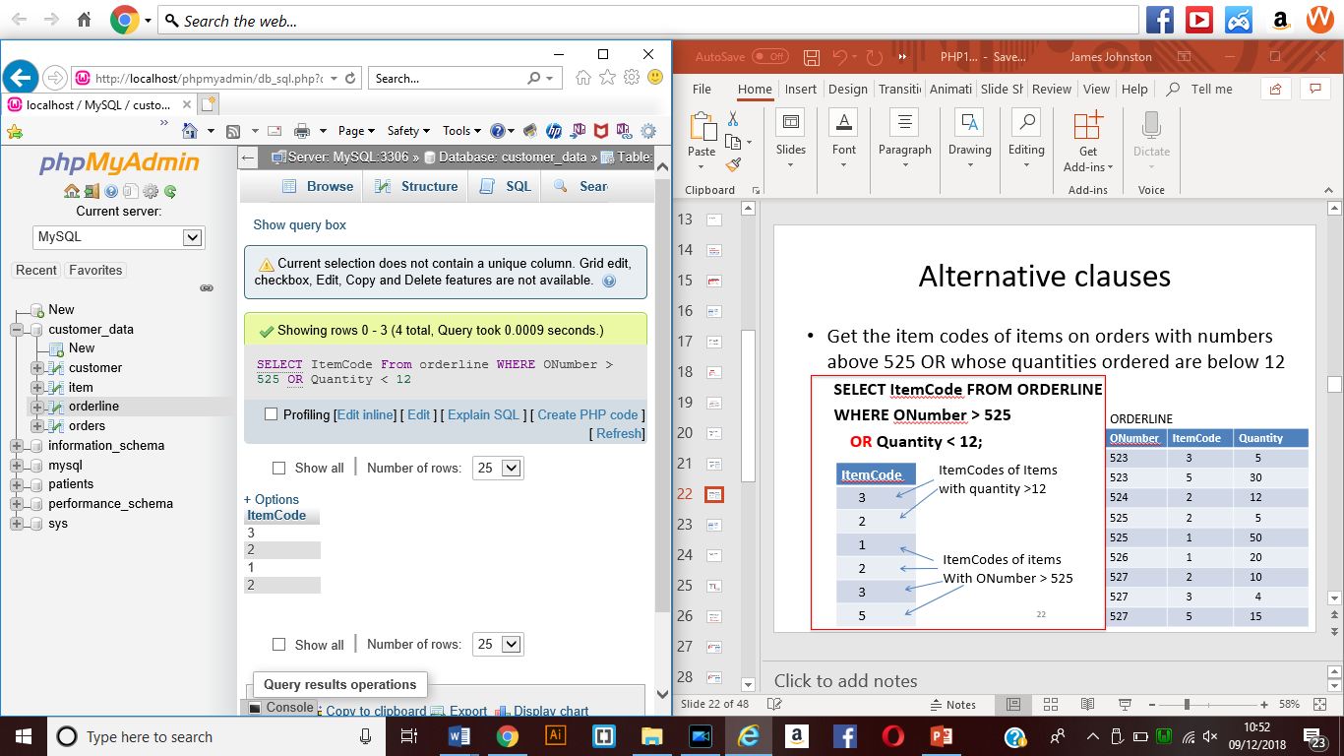

1212 – Select Statement to get the item code of items on orders which are abover 525 and below 12 for quantity and sorted by quantity in descending order

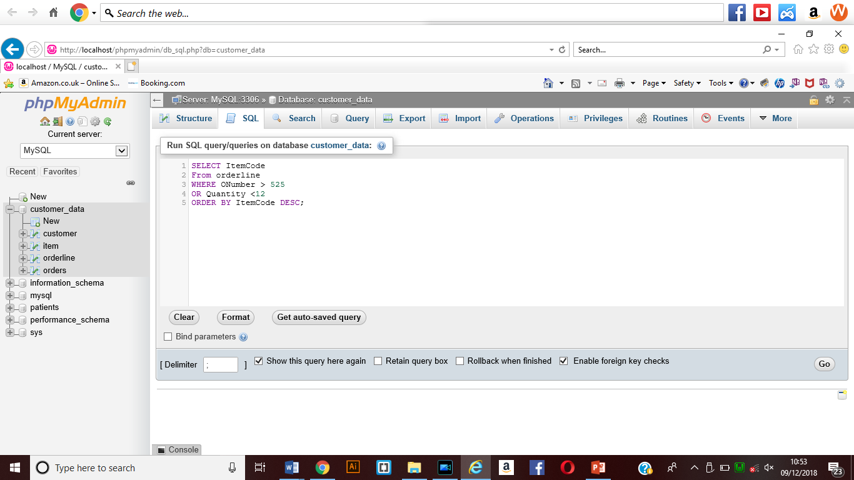sql statement placed in the sql area on PHPMYADMIN

Statement written

SELECT ItemCode

FROM orderline

WHERE ONumber >525

OR Quantity < 12

ORDER BY ItemCode Desc;

Result

